State of Rhode Island Covid-19 Test Kit pickup location.
2700, Plainfield Pike, Cranston RI.
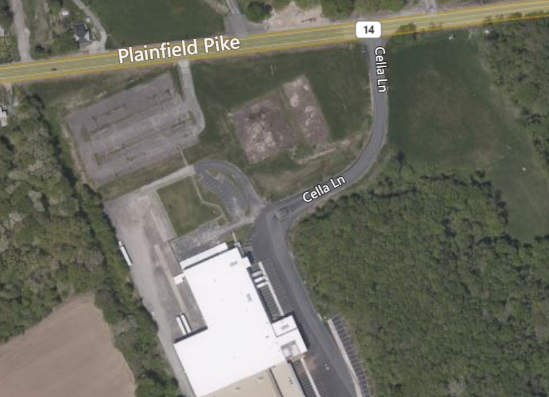

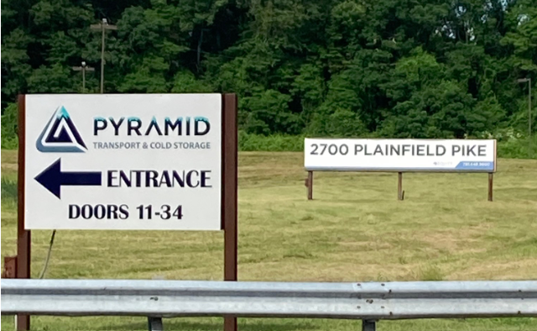

Signs out front.
Pickup tent is around back of the warehouse

Hours: 8am to 3pm, Monday and Thursday.
Enter by Cella Lane.
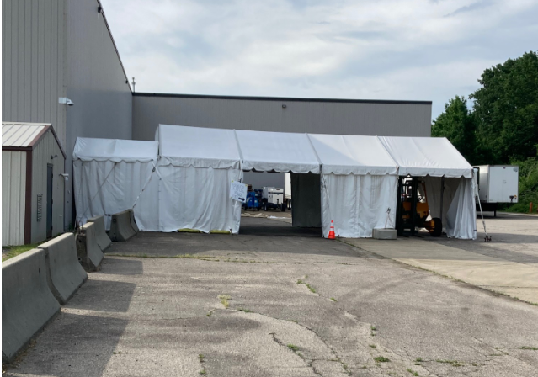
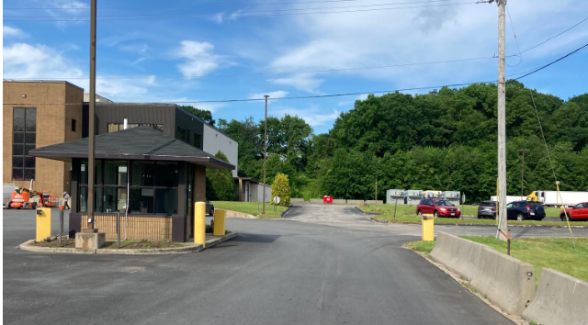

Turn right just after the guard shack. Follow road around. Pull into the pickup tent.

NOTES: Off 295, take Plainfield Pike westbound.
You know you are getting close when you are approaching the windmills.
The location is the same location used for PPE pickups.

